Applications

***Rand. Sampling***

***Paint-to-image***

***Editing***

***Harmonization***

Introduction

***GANs*** have attracted a lot of attention thanks to their ability to generate realistic images.

However, they are very hard to train and hence require a great amount of training images, to learn a good representation of features, especially when the images are complex.

***SinGAN*** is a new approach which trains on a *single* image, using a pyramid of fully convolutional lightweight GANs each responsible for capturing the distribution of patches at different scales.

***My project*** aims at studying the applications of SinGANs and extending them to inpainting (“*fill in the box*”) techniques.

Inpainting with SinGANs

MEGI DERVISHI

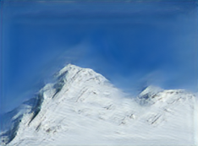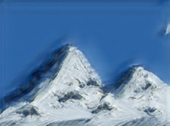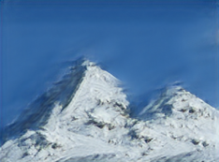

Painted image

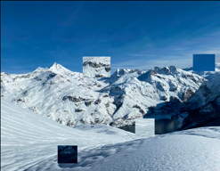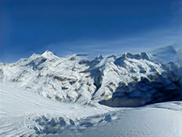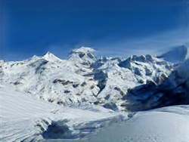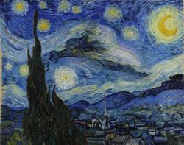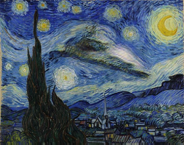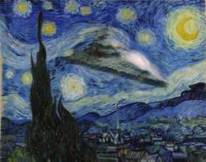

***Style transfer***

MEGI DERVISHI

MVA: DEEP LEARNING

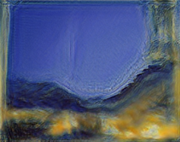

[***Animation***](https://github.com/MegiDervishi/singan_res)

* Interpolation Bicubic / Bilinear
* User study

***Irregular boxes***

***Regular boxes***

Inpainting

***Train on cropped image:***

***Fill the box with avg. neighb. color***

***Harmonization***

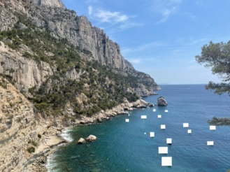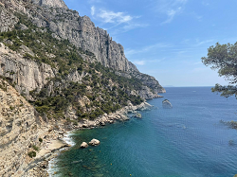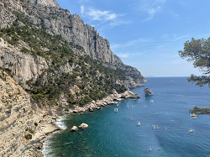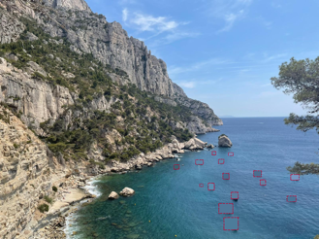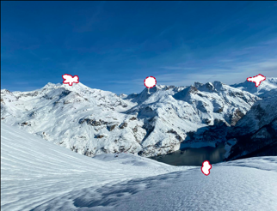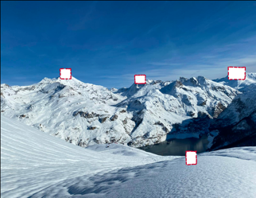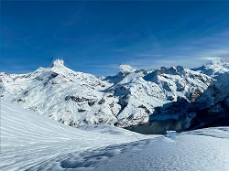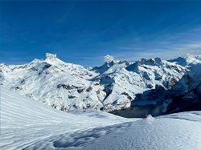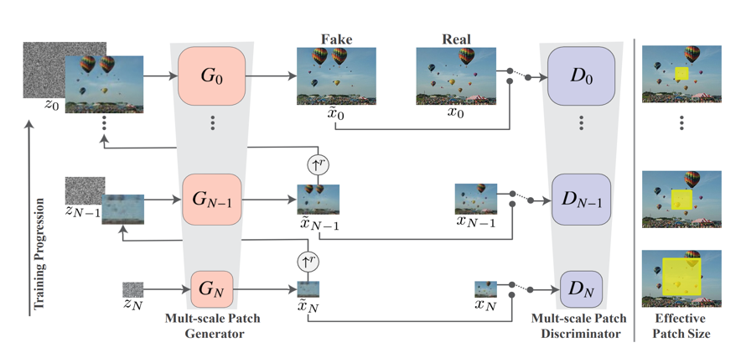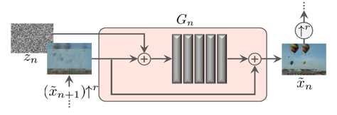

Structure

Next

***Regular vs Irregular***